3.6: Low-Fidelity Prototyping: Paper & Sketches

Learning Goals

Create low-fidelity paper prototypes for desktop and mobile

 Estimated Read Time: 30 Minutes.

Introduction

Welcome back! So far in this Achievement, you’ve gotten the chance to put your new understanding of design patterns and heuristics to use by creating prototypes of the most important features of your app. Now that you’ve got a little bit of practice creating prototypes, let’s take your knowledge to the next level by learning about the importance of sketching low-fidelity prototypes and how to do it.

Believe it or not, in today’s high-tech world, drafting designs on paper is still hugely valuable and very widely used. Paper is a forgiving medium, since you can easily make changes or scrap the design and start over. This makes paper prototyping very appealing in the early stages of app design. Towards the bottom of this Exercise, we've provided you with an instructional video on how to use pen and paper to create a low-fidelity prototype for your own project. Be sure to check it out!

However, before we get into the specific tools and techniques for paper prototyping, it’s important to make a distinction between wireframes and prototypes.

Wireframes vs. Prototypes

As you continue to grow in the field of UX design, you’ll hear people use the terms "paper prototypes" and "wireframes" interchangeably. While there's no need to get too hung up on words, having a solid understanding of the distinction can help you more fully comprehend design processes and manage your own design workflow.

A **wireframe**, like the one you created in Exercise 3.3: Navigation for Mobile & Desktop, is a static, visual representation of an interface. A **prototype**, on the other hand, can be a combination of wireframes and portrays specific interactivity between functional elements rather than merely the visual structure of an interface.

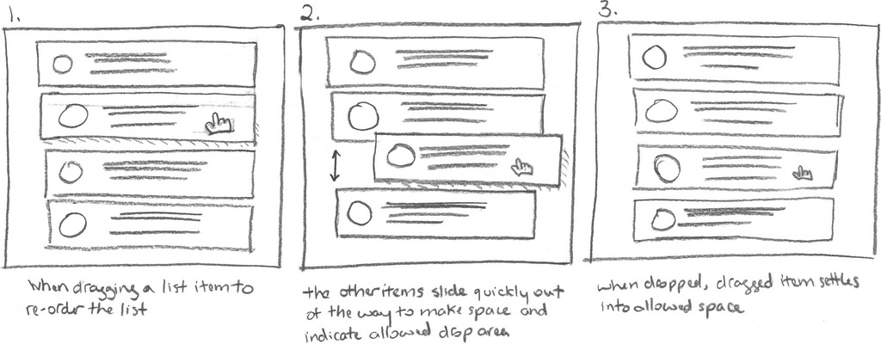

Source: [Rosenfeld Media](https://www.flickr.com/photos/9411449@N05/28376741725)

A prototype can be as simple as the example above, or it can be more complex, based on final design drafts with interactive, clickable elements and animations. We’ll talk more about these more complex prototypes in Exercise 3.9: High-Fidelity Wireframes & Clickable Prototypes.

In short, a wireframe depicts a static piece of an interface, while a prototype represents an interaction or a flow of functionality.

Design Fidelity Revisited

In Exercise 5 of the Fundamentals Course, we talked about how **design fidelity** refers to how closely the wireframe, prototype, mockup, etc. matches the look-and-feel of the final system. Throughout the design process, the level of fidelity is continuously modified and increased based on user feedback, research, and design iterations. Therefore, it’s important to keep in mind that design fidelity is more like a status than an end state. The image below illustrates how fidelity increases throughout the design process; as the fidelity increases, more time is spent on the details of the prototypes.

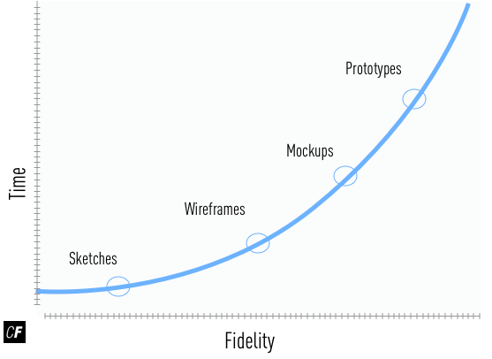

Let’s take a closer look at each level of prototype—low-, mid-, and high-fidelity—to get a better understanding of how you can use them in your work.

Low-Fidelity Prototype

A **low-fidelity prototype** is meant to highlight only the high-level functionality of a design. It purposefully glosses over the intimate details of a design such as color, spacing and imagery and is usually hand-sketched in black and white or grayscale.

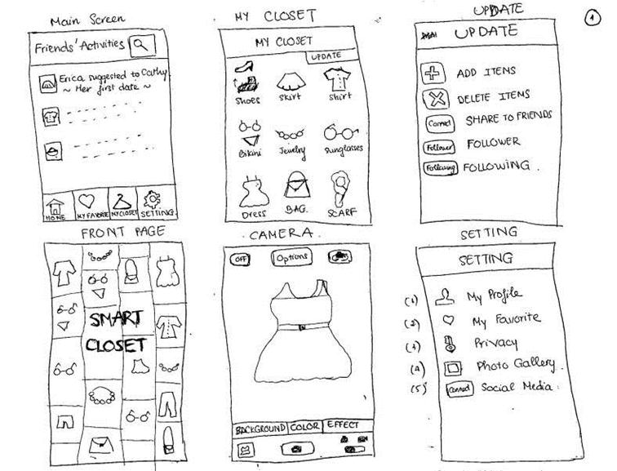

Source: [Infosec Institute](http://resources.infosecinstitute.com/prototyping/#gref)

The image above showcases a set of hand-drawn wireframes that've been grouped together to represent a user flow, making them a low-fidelity prototype (as opposed to simply low-fidelity wireframes). While the presentation is very simple, it's still able to display what type of interaction the designer has in mind for the app without requiring every single element or line of code that would go into the final app. This means that all stakeholders can agree on the base functionality before valuable time and resources are put into building the app. If someone disagrees, the prototype can be tweaked in a matter of seconds.

Low-fidelity prototypes are typically done on paper, but they can also be done digitally. Below is an example of a very basic, low-fidelity, clickable prototype made using Balsamiq.



The adjective “low” does not imply that it's of low value. In fact, it’s crucial to start with a low-fidelity prototype as it allows designers to focus on the core structure and navigation of the app rather than on pixel-perfect visual design features and complex functions. The more elaborate design elements can wait until the project reaches the high-fidelity prototype phase. For now, only high-level functionality should be the primary focus.

Mid-Fidelity Prototype

As the name implies, **mid-fidelity prototypes** portray a bit more detail than low-fidelity prototypes, but they're not as polished as high-fidelity prototypes. They're usually created using software such as Adobe XD, Balsamiq, UXPin, or Photoshop. The advantages of a mid-fidelity wireframe or prototype are:

1. It’s digital, so it can easily be shared with others. Many wireframing and prototyping programs have built-in sharing tools to simplify this exchange.
2. It’s still very easy to make large, rapid changes to a design.

Below is an example of a basic mid-fidelity prototype of a website. Notice that the placement and basic visuals have been perfected, but the design is completely grayscale with no color or graphics.

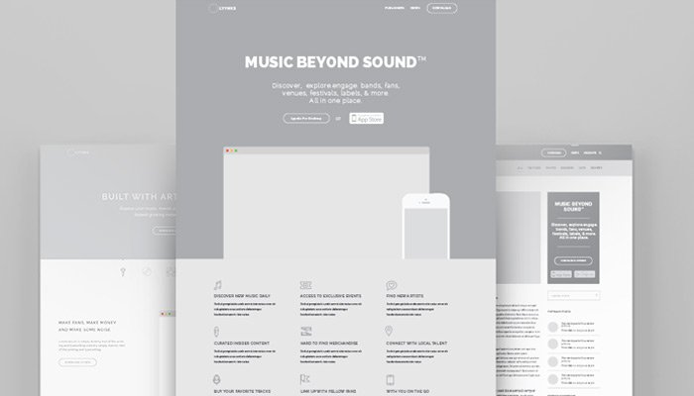

Source: [Michael Pons](https://dribbble.com/shots/1999781-Optimized-Landing-Page)

High-Fidelity Prototype

Finally, you're at the high-fidelity prototypes phase! Unlike mid-fidelity prototypes, **high-fidelity prototypes** take much longer to create as the goal is to flesh out every single detail of a design. They should look and feel like a live system in terms of graphics, spacing, and layout and closely resemble the finished product.

Below is an example of a high-fidelity prototype. Notice that it feels like a fully functional application.



Source: [Grzegorz Oksiuta](https://dribbble.com/shots/2075528-KickMaterial-Category)

Once a high-fidelity prototype is complete, it can be very time-consuming to alter even the smallest details, which is why low-fidelity prototyping is so valuable in the early phases of app design. It offers a great way for designers to continue to “level up” to prototypes of higher fidelity. This iterative approach allows designers to change a design rapidly for little cost or time investment.

It’s easy to get confused, but just remember this:

**Low-Fidelity Prototype = High-level details**  
Shows the high-level (general) user experience and gets everyone aligned with the big picture.

**Mid-Fidelity Prototype = Medium-level details**  
Shows off a bit more design detail and basic interactivity.

**High-Fidelity Prototype = Low-level details**  
Shows how the polished app will look, feel, and function.

Paper Prototyping Mediums

Prototyping may seem as simple as drawing circles and squares on a sheet of white paper, but there’s more to it than that. There are several mediums for creating prototypes, and which one you choose will depend on what you prefer as a designer. The following are some of the most popular choices.

Sticky Notes

If you’re a visually oriented person, you might have a hard time forcing yourself to ignore the small details when drafting a prototype. Luckily, there’s a type of prototype that makes focusing on details nearly impossible.

As you may have guessed, sticky-note prototyping is when you prototype your designs and interactions on a 3-inch by 3-inch sticky note (such as a Post-it note, for example). Because you’re working with such a small space, you won’t be able to focus on the small details even if you wanted to. You can even try drawing exclusively with a large-tip marker. This forces you to keep your eyes (and mind) on the big picture and the overall flow of your design rather than getting distracted by all the little bells and whistles.

Another great advantage to the sticky note method is that each note is portable and adhesive. This allows you to move them around, reorganizing elements and screens in real-time!

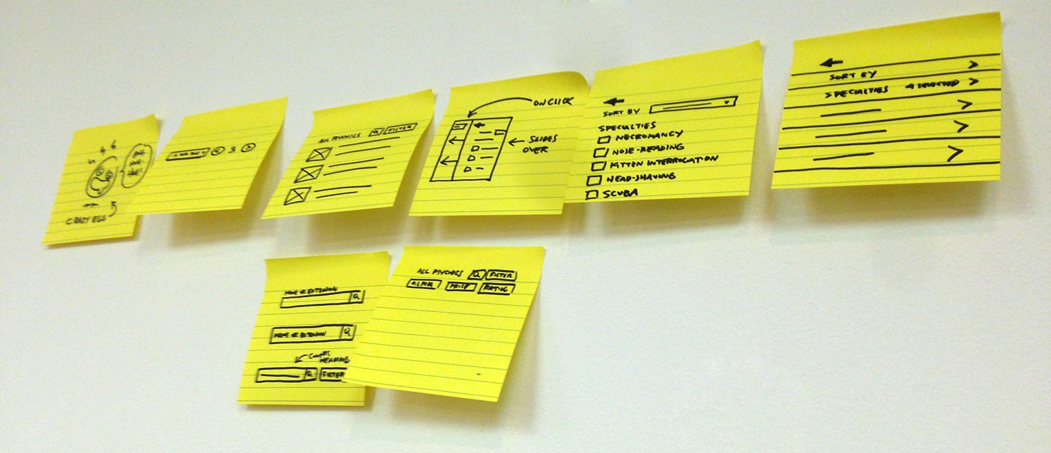

Grid and Dot Paper

One prototyping medium favored by many designers is grid paper. Unlike a white sheet of paper, grid paper allows you to draw straighter lines and measure things out without the need of a ruler. When working with grid paper, it’s a good idea to use a mechanical pencil, as the tip is very fine and allows you to draw precisely.

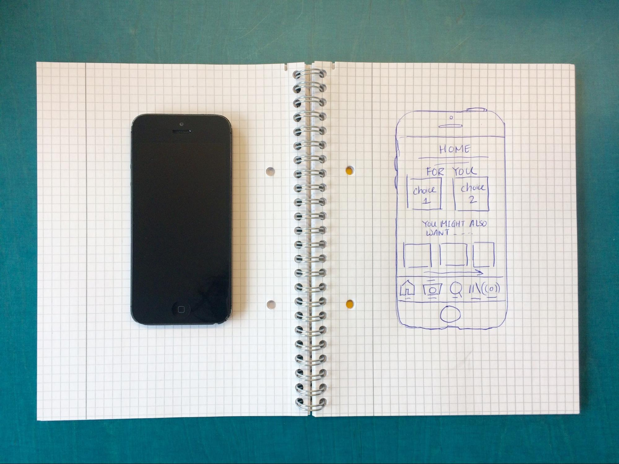

Some designers feel like grid lines can be a bit distracting. If you feel this way, check out dot grid paper. It’s similar to grid paper but made up of dots instead of grid lines.

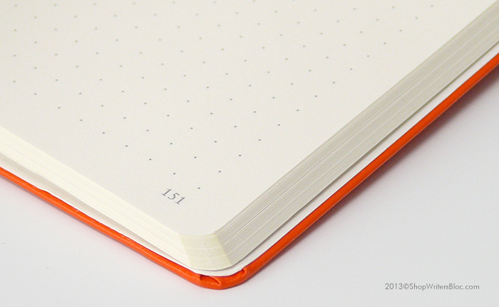

Source: [Writer’s Bloc](http://www.shopwritersbloc.com/leuchtturm1917-dot-grid-notebook-large-hard-cover-orange.html)

It can be difficult to refrain from adding low-level detail when using either style of grid paper. If you’re having trouble, try using a large-tip marker! You can still use the grid as a general guide, but, like the sticky note method, it’ll help you focus on only the high-level details. You can even cut out individual screens so that it’s easy to arrange them on a table and experiment with different flows.

Note Cards

Another method that's great for mobile prototypes is the use of note cards to represent different screens of your app. It can be difficult finding note cards that are close to the actual size of a phone screen, but one trick that works well is to buy a box of standard-sized note cards and cut them down to the appropriate size.

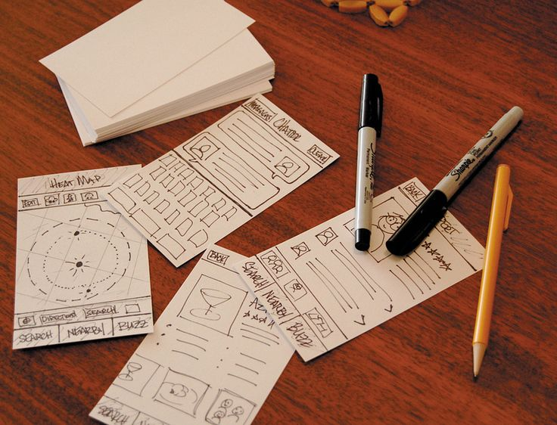

Stencils

A stencil is basically a shell that represents a specific platform. Drawing your designs within a shell makes it much easier to visualize how your interactions will feel on the device.

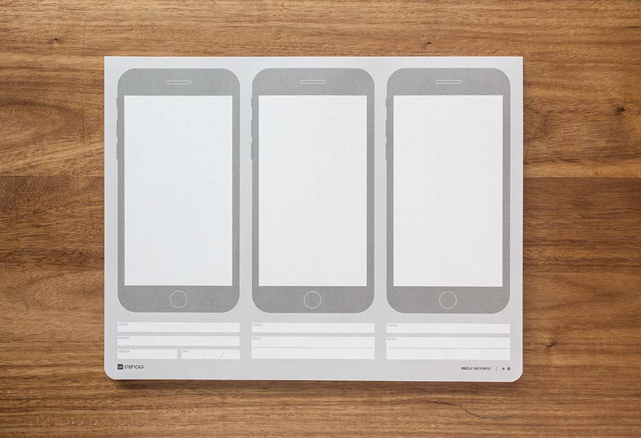

There are stencils for each iPhone and Android phone size, desktop applications, and even the Apple Watch! Some stencils are professionally produced and can be purchased online. Others can simply be downloaded for free and printed out. Take a look at the links included in the Resources section for additional information on prototyping stencils.

Creating Low-Fidelity Paper Prototypes

Armed with the prototyping tool that feels most intuitive and hands-on to you, you're now ready to create low-fidelity paper prototypes. As mentioned in the previous section, the focus at this stage should primarily be on functionality, and you’ll begin with a key feature of your app.

Here are the general steps for creating your low-fidelity paper prototype.

1. Decide which feature you’ll be prototyping and the medium you’ll be prototyping on (we recommend you use the same features you wireframed in Exercise 3.4).
2. Make a list of the key screens you’ll need to design in order to complete this function. If necessary, refer back to your user flows from Exercise 2.6: Task Analysis & User Flows, as well as 3.3: Navigation for Mobile & Desktop.
3. For each page or screen, make a list of the key elements you’d like to include such as navigation, photos, sections, and any other page elements. This step helps you collect your thoughts and get an overall idea of what you'll need to include.
4. Start drawing out your wireframe one element at a time, making sure to focus on only high-level functionality of the feature rather than small design details such as spacing, color, and detailed imagery.
5. If necessary, erase and redraw sections or scrap entire pages and start over. Since you’re only designing a low-fidelity paper prototype, it’s easy to rapidly iterate over your designs. In order to keep from getting hung up on the details, try limiting your time on each iteration to no more than 10 minutes.

With these steps in mind, check out the following video on how to create a low-fidelity prototype using good old pen and paper.

Pros & Cons of Paper Prototyping

As with everything, paper prototyping also has a “dark side.” Let’s take a look at the pros and cons of paper prototyping below. You’re also encouraged to start thinking about strategies that will enable you to make the most out of your paper prototypes.

| **PROS** | **CONS** |
| --- | --- |
| **Rapid iteration**: Paper prototypes are quick to create and easy to modify. Because of this, anyone can participate in creating paper prototypes. | **Limited interaction**: Certain elements of interaction can't be realistically or effectively conveyed on paper. |
| **Inexpensive**: Because they're quick to create, paper prototypes don’t cost much, but that doesn't mean they can't still add a lot of clarity to a project. | **Not always self-explanatory**: Because of the simplicity, paper prototypes require effort in accurately communicating the design as well as the intention. |
| **More creativity**: Because you aren’t concerned with the small details or bogged down by clunky software, your imagination is free to run wild! | **Missing minor details and potential errors**: Similar to the above issue, the lack of detail makes it difficult to evaluate or foresee minor issues down the road. |

Summary

In this Exercise, we took a trip through the world of low-fidelity prototyping and learned how they can be used to flesh out interaction ideas rapidly at little cost. You also learned about specific paper prototyping mediums you can use to create your prototypes.

In the following Exercises, you’ll continue to fine-tune your prototypes from low- to high-fidelity. In this Task, we'll start with low-fidelity, and you’ll be using what you learned to create paper prototypes for your app. Let’s get started!

Resources

* [Faking It Until You Make It by Interaction Design Foundation](https://www.interaction-design.org/literature/article/rapid-prototyping-faking-it-until-you-make-it-in-a-ux-driven-world)
* [TempTraq Case Study by SmartShape](https://smartshape.design/work/temptraq)
* [Stop Talking and Start Sketching: A Guide to Paper Prototyping](https://blog.marvelapp.com/stop-talking-start-sketching-guide-paper-prototyping/)

UI Design Stencils

* [iPhone Stencil Kit](https://www.uistencils.com/products/iphone-stencil-kit)
* [Watch Doodlers by Jed Bridges](https://dribbble.com/shots/1718858-Watch-Doodlers)
* [Mobile Sketch Pad](https://www.uistencils.com/products/iphone-sketch-pad)
* [Sketchize](https://sketchize.com/)

Take the quiz to test your knowledge on this Exercise.

Take Quiz

Task

* [DIRECTIONS](https://careerfoundry.com/en/course/become-a-ux-designer/exercise/low-fidelity-prototyping#directions)
* [SUBMISSION HISTORY](https://careerfoundry.com/en/course/become-a-ux-designer/exercise/low-fidelity-prototyping#step_submission_history)

 Estimated Task Time: 6 Hours.

Using your refined sitemap from Exercise 3.2: Refining Your Sitemap with Card Sorting, the user flows you created in Exercise 2.6: Task Analysis & User Flows, and the techniques you learned in this Exercise as a reference, generate paper prototypes for the 3 core features of your app.

**Directions**

1. Decide on a paper prototyping medium you’d like to use to create your prototype. You can even try all of them if you’d like!
2. Take a look at the wireframes you made in Exercise 3.4: Design Patterns for Mobile & Desktop. These are static screens that each represent a key feature of your app. Now, it's time to translate these screens into prototypes. Rather than a single static screen, you should have multiple screens for each prototype—a series of screens that follows the entire user flow for a specific function. [Check out this example from the demo app](https://s3.amazonaws.com/coach-courses-us/public/courses/ux-immersion/A3/E6/A3E6_demoproject_lo-fid_prototype.JPG) if you need some inspiration.
3. Using the step-by-step instructions from this Exercise as a guide, create both mobile and desktop paper prototypes for each of your app's 3 core features. This means that you should have 3 mobile paper prototypes and 3 desktop paper prototypes. You can choose the number of screens (wireframes) for each of your prototypes; the key is making sure that you have clearly communicated how each of your 3 core features will function.
4. Take a photo of each of your paper prototypes and combine them into a single PDF. Upload it here for you and your Tutor to discuss!